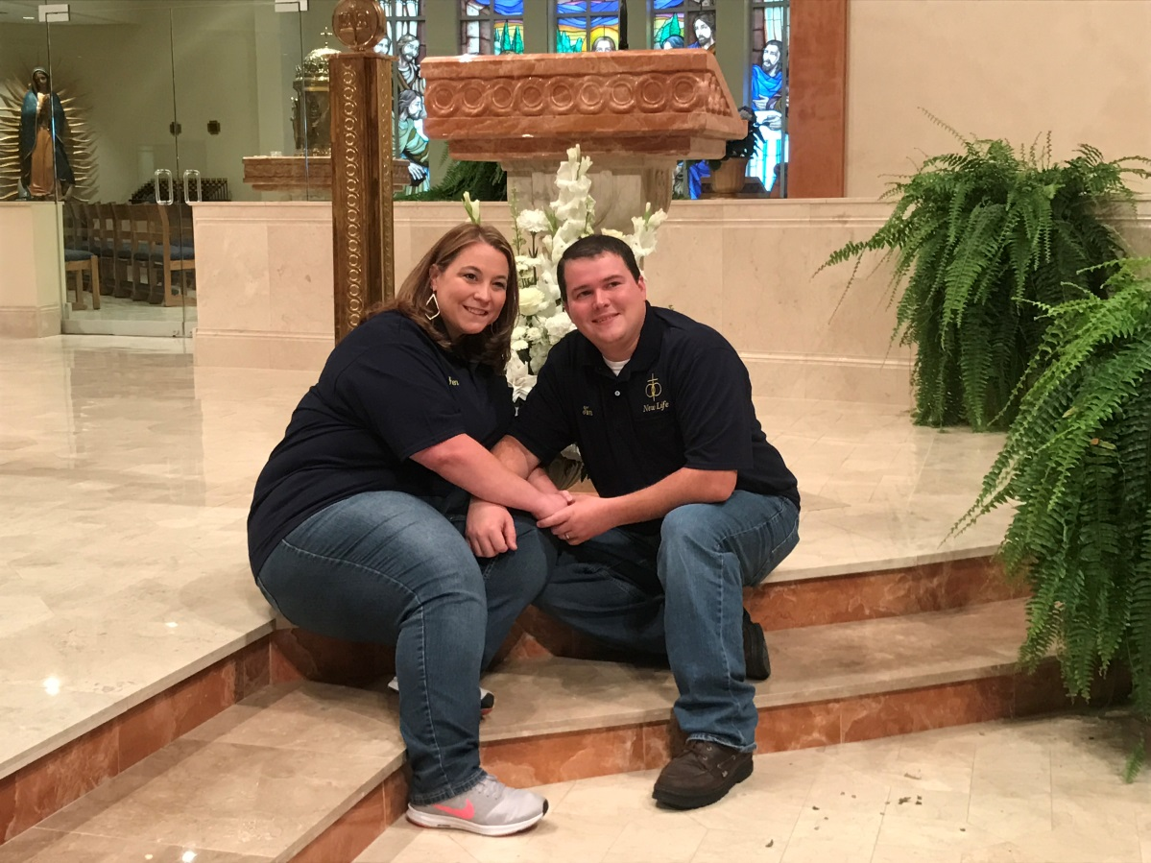
Tim and Jen Alexander

Tim
- My name is Tim. We joined the New Life Team in June of 2017. My first marriage only lasted one short year before ending in a divorce in 2008. I met Jen on Catholic Match in 2012. Due to the timing of our annulment to be approved we chose to be married by the Justice of the Peace several short months later. We did get our marriage blessed in the church but first attended New Life as part of our requirements. With our busy schedule we were not happy about taking a whole Saturday away from our now two children. Looking back now, we are sure happy we took that time for our relationship and we joined the New Life team.
Jen
I’m Jen. My first marriage ended in divorce after 5 years and one small child in 2009. We met on Catholic Match in early 2012 and knew we were each other’s Happy Ever After. In 2016 both of our annulments were approved, and we were very excited to be able to get our marriage blessed in the church and started on our path of Convalidation of Marriage. Part of that was attending a New Life retreat. It was the best thing for our relationship. We joined the New Life team not only to help others but allows us to do a “Couples Check” for our relationship.

Hello! We are Tim and Jenn Alexander. We joined the New Life Team in June of 2017. Tim’s first marriage only lasted one short year before ending in a divorce in 2008. Jenn’s first marriage ended in divorce after 5 years and one small child in 2009. We met on Catholic Match in early 2012 and knew we were each other’s Happy Ever After. Due to the timing of our annulment to be approved we chose to be married by the Justice of the Peace several short months later. In 2016 both of our annulments were approved, and we were very excited to be able to get our marriage blessed in the church and started on our path of Convalidation of Marriage. Part of that was attending a New Life retreat, with our busy schedule we were not happy about taking a whole Saturday away from our now two children. Looking back now we are sure happy we took that time for our relationship. We joined the New Life team not only to help others but allows us to do a “Couples Check” for our relationship.
----------version 2

