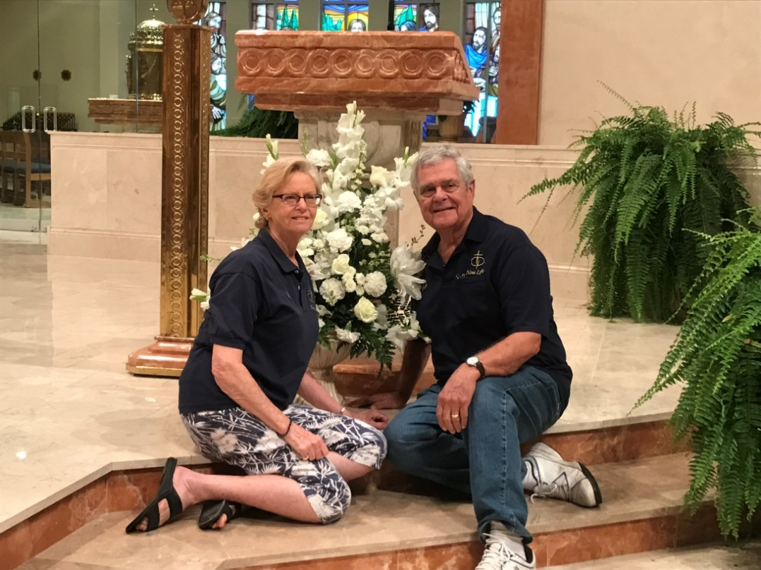
Frank and Sandy Bianco

FRANK
I was married for 31 years, and had 4 grown children. After my divorce, I attended several Catholic self help programs including RSVP, and Journey. Sandy and I have now been married for 26 years and have been part of New Life team since then. Over these many years we have learned so much about remarriage and feel this group continues to help us maintain a wonderful marriage.
SANDY
I was married for 13 years to my high school sweetheart. I was single for 13 years after my divorce and had no intention of remarrying. I was enjoying a great career with the airlines. Then, along came Frank. After several years of dating, I finally “let go and let GOD”, and what a wonderful decision that was. I never had children, and now I have a wonderful extended family of 4 children and 12 grandchildren with our 1st great grand child due soon. The tool box from New Life has allowed us to maintain our positive and loving relationship for 26 years. Life is good.

