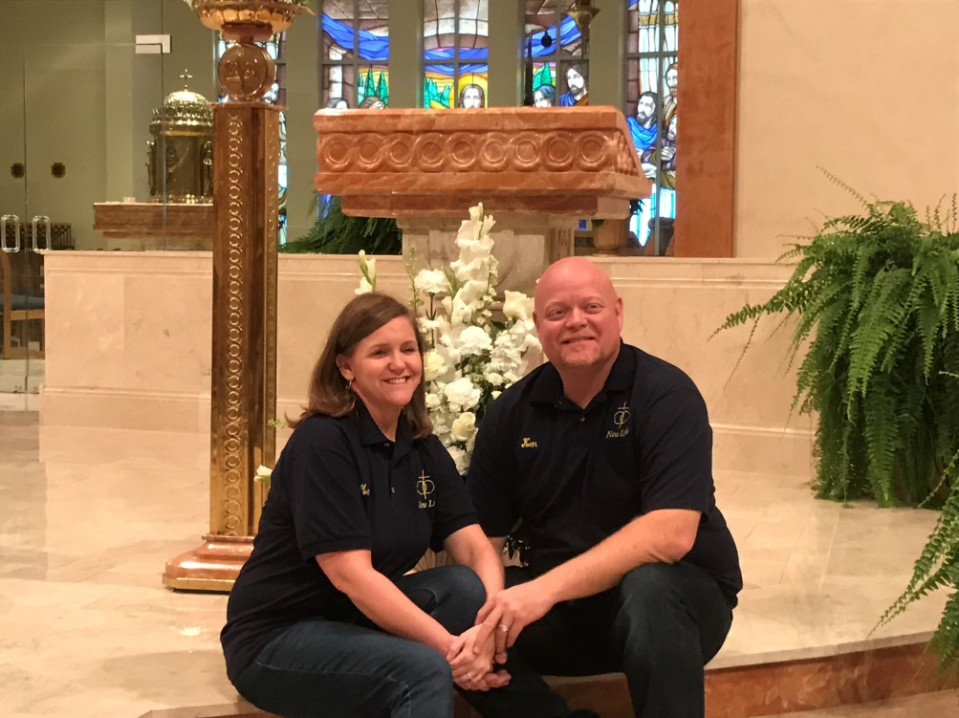
Ken and Mendy Witzenman

Mendy:
I was married for 8 years before my divorce. We were together for a total of 15 years. There were two children from this marriage. I received an annulment after the divorce was finalized.
Ken:
I was married for 20 years before my divorce. There were 4 children from this marriage. We were never married in the Catholic Church so there was no need for an annulment.
We met on Catholic Match. We both wanted to be remarried in the church and make sure God was central in our relationship since our previous marriages were missing this element. We met with the priest at our parish and he strongly encouraged us to attend New Life as part of our marriage preparation. We were interested because we were blending a family and knew this process would be very difficult. After attending the retreat, we were hooked and wanted to be part of the team in order to help others work through the remarriage process. We use New Life as a way to help others and work on our marriage at the same time.

