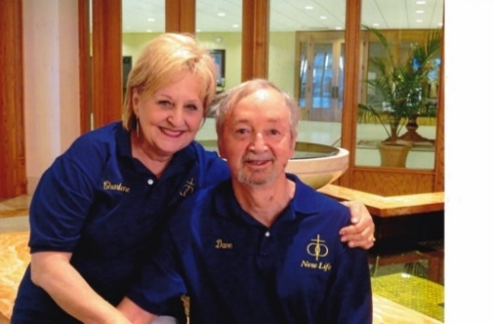
Dave and Charlene Jones
Dave:
My name is Dave and I was married for 7 years, separated 3 years, and divorced. I was a single parent for my daughter for 10 years before I married my wife, Charlene. My daughter now lives in Denver. There are many reasons why I come to New Life. The first is because we have been doing New Life for 30 years and I enjoy being a part of something that is so very important. Another reason why I am a part of New Life is so that I can be with my wife for a whole day!
Charlene:
My name is Charlene and I was married 17 years and divorced for 6 years before Dave and I married. I have three children, who, at that time, were 5, 11, and 13. So, when we married, we have 4 children in our blended family. They are now all grown and on their own. We have been blessed with 5 grandchildren and 2 step-grandchildren, again, always blending. This is a part of being remarried as the dynamics of being a remarried couple is different. It is not like being married a first time. This is why I am a part of New Life.

