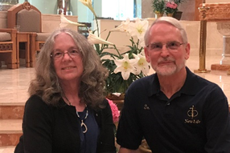
Don
I have been married to Barbara for over 25 years following my previously 13-year marriage that ended in divorce and annulment. When Barbara and I married, I brought two young children with me into our new family. It was shortly after our marriage when we first attended New Life. Little did I know that remarriage is so much more complicated than a first marriage. The New Life program helped me to examine my actions, thoughts and feelings and how those either built or damaged my relationship with Barbara. Getting married is easy but being married takes work, work that is so important, valuable and rewarding. I look forward to sharing the struggles and the joys of remarried life with you.

Barbara:
I was married for 13 years before divorce and annulment. I had 3 children from that marriage. When Don and I married, two of my children were young adults with kids of their own while the youngest was a teenager. Don became an instant grandpa. We knew God had a sense of humor when Don and I became parents again, so we are a Yours, Mine and Ours family. Marriage is hard and remarriage can be harder. New Life gave Don and me the tools we needed to navigate the roiling seas. I look forward to working with you on your own journey.

